500cc Royal Enfield Bullet 2007

EEC specification
5 speed immaculate condition, only 1,220 miles with 1 expatriate owner

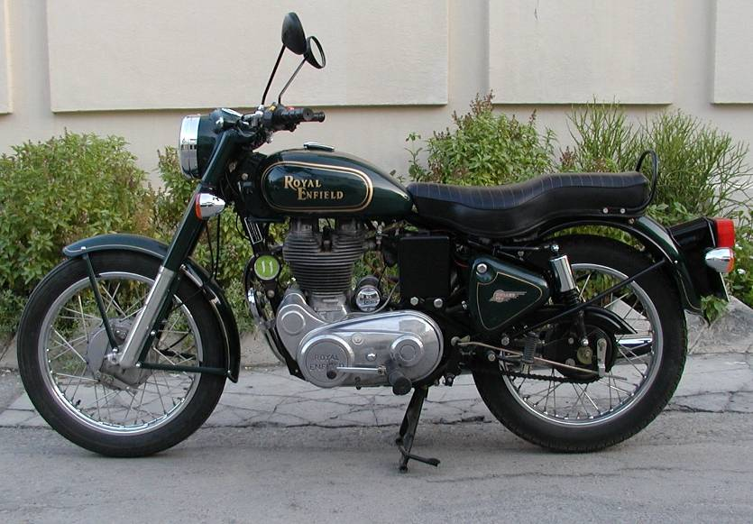

Complete and full service history, kept in top condition.

Indian made, your chance to own a British Classic, easy to start and maintain.

Low mileage.

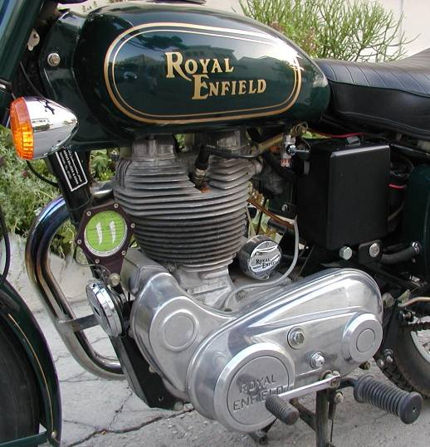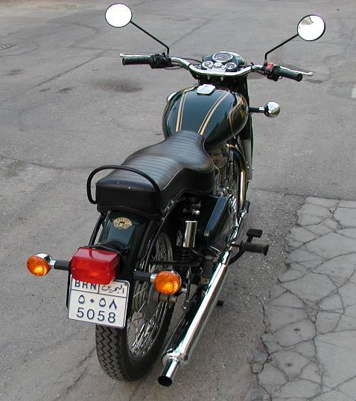

Relocation sadly forces sale of much loved and dare I say much admired motorcycle. The Bullet is made from a 1949 design in India, and has won many friends globally. With the ‘retro look’ and up to date technology this stunning, easy to ride, economical to insure and fun machine is really fun.

For the amateur mechanic, this machine is easily maintained as well. Although fitted with an electric start, the purists amongst us will enjoy the easy kick start. The machine is run in and ready to go and is used regularly.

I will provide full riding instructions, starting advice and tips. I have all documentation as provided.

There is a full tool kit, spare inner tube, some spares and panniers (leather/plastic).

Sensible offers please

