SUPPORTED BY:

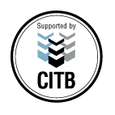

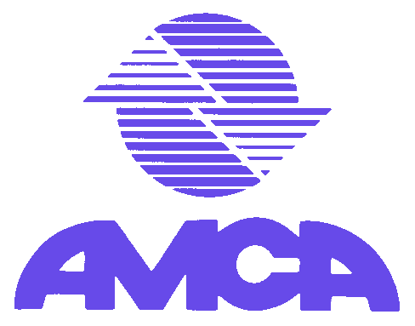

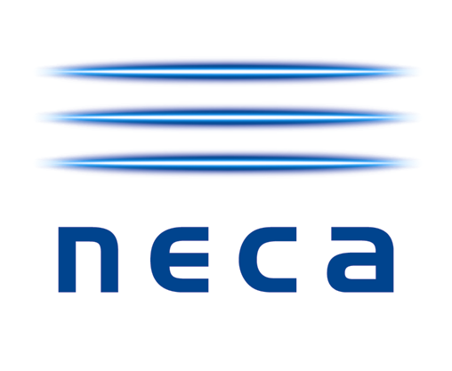

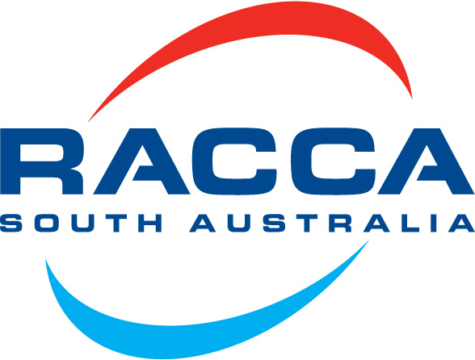



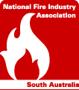

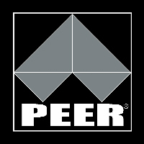

1042 Port Road
Albert Park SA 5014

Tel: (08) 8348 1200
Fax: (08) 8348 1201
E-Mail: peertec@peer.com.au
Web: www.peer.com.au

Plumbing, Electrical, Electronic and Refrigeration Technical Education Centre Incorporated

Price List

(Effective: 8 JULY 2008)

UPSKILLING PRICES |  |  |  |  |  | Industry Association Members
Service Code | Courses | Hours | Regular Price | With CITB rebate |  | Industry assoc.  Regular Price | Industry & CITB | Industry Associations for subsidy purposes
 | NO GST |  |  |  |  |  |  | Industry Associations for subsidy purposes
914 | Open Registration | 40 | $745.00 | $275.00 |  | $670.50 | $200.50 | NECA
888 | Structured Cabling | 16 | $475.00 | $255.00 |  | $427.50 | $207.50 | AMCA
133 | Coaxial Cabling | 8 | $250.00 | $140.00 |  | $225.00 | $115.00 | ARTIC
134 | Optical Fibre | 24 | $735.00 | $435.00 |  | $661.50 | $361.50 | NFIA
491 | Restricted Registration | 16 | $450.00 | $150.00 |  | $405.00 | $105.00 | RACCA
883 | Wiring Rules AS/NZ3000:2007 | 36 | $510.00* | $90.00* |  | $459.00* | $39.00* | PIA
56 | Single Phase Self Testing | 12 | $380.00 | $210.00 |  | $342.00 | $172.00 | MPA
1311 | Occ. Health & Safety (NBB002.1) | 20 | $460.00 | $160.00 |  | $414.00 | $114.00 | ASIAL
53 | Power Tool Testing | 8 | $275.00 | $165.00 |  | $247.50 | $137.50
1317 | Security 1 | 40 | $725.00 | $255.00 |  | $652.50 | $182.50
1318 | Security 2 | 40 | $725.00 | $255.00 |  | $652.50 | $182.50
636 | Security Fastrack Course | 21 | $510.00 | $250.00 |  | $459.50 | $199.00
- | Electro Comms Prin.– Correspondence | 40 | $240.00 | NA |  | NA | NA
 | INCLUDING GST |  |  |  |  |  |  | Reference Books
57 | Tendering & Contracting | 40 | $720.00 | $250.00 |  | $648.00 | $178.00 | # * 3000:2007 - $125.00
388 | Small Business Management | 60 | $1,160.00 | $490.00 |  | $1,044.00 | $374.00 | (NECA members receive $25 discount on this book only)
 | Trades Test (all trades) |  | $330.00 | NA |  | NA | NA
111 | Restricted Elect. for Plumbers | 16 | $450.00 | $170.00 |  | $405.00 | $125.00 | *3008 - $120.00
1310 | National Restricted Elect. Licence | 24 | $450.00 | $230.00 |  | $405.00 | $185.00 | *3012 - $85.00
1314 | Rescue & Resuscitation | 5 | $120.00 | $50.00 |  | N/A | N/A | *ETSA rules - $15.00
1362 | Whitecard | 6 | $80.00 | $10.00 |  | N/A | N/A
 | Wiring Rules update (2007) | 8 | $160.00# | $50.00 |  | $144.00# | $34.00

- NOTE: All prices include text books, materials etc unless indicated. Prices are current at time of printing though subject to change
* Requires all reference books marked with * Total $345.00
# Requires all reference books marked with # Total $125.00 (unless NECA member $100.00)

